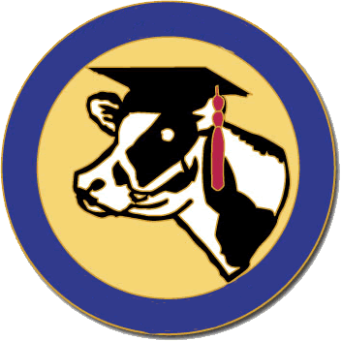
National Holstein Women’s Scholarship Organization
2019 Scholarship Application Form

- Personal Information (5 pts)
Personal/Contact Information
Full Name: __________________________________________________ Birth Date: _______________________
Cell Phone: ________________________________ Email: ______________________________________________
Home Address: _________________________________________________________________________________
School Address: _________________________________________________________________________________
Parents’ Name: _________________________________________________________________________________
High School GPA: _____________________ Date of High School Graduation: _________________________
Name of College, University or Technical School: _______________________________________________________
Cumulative College GPA: ________________ Year in College (Fall ’18): ________________________________
Major: ________________________________________________________________________________________
Farm Information
Dairy Cows: ________________ Dairy Heifers & Calves: __________________ Other: _____________
Your Holstein Project
Dairy Cows: ________________ Dairy Heifers & Calves: __________________ Other: _____________
I am a Junior Holstein Member: (State) _______________________ (National) ________________________

- College Transcript (5 pts)
Please enclose your official college transcript of grades for the Fall 2018 semester. Electronic transcripts are acceptable.

- Resume (25 pts)
Include your professional resume of college activities, work experience, volunteer experience, awards and achievements, etc. Please use at least a 10-point font, and limit your resume to one page.
- Personal Opinion Essay (25 pts)
Choose one of the following two topics and in 500 words or less, please discuss your opinion.
- With the evolving gap between urban and rural living, what will be essential for dairy farmers to connect with their consumer?
- What will state and national breed associations look like in the future as they maintain their relevance and thrive in an age of fewer, but larger farms?

- Personal “Ad” (40 pts)
Design and submit an “ad” describing yourself, and your farm/industry involvement. Be creative to allow the judges to get a better sense of who you are and what you are passionate about. The Ad should be approximately 8.5” x 11” and may be color or black & white. This ad may be similar to an ad you might do about one of your cows and why somebody should buy her, but instead do it about yourself and why you should be selected to receive a NHWSO scholarship. Submit the ad as a pdf file.
The 2018 NHWSO application consists of 5 parts as follows: (1) signed personal/contact information form, (2) official college transcript, (3) resume, (4) personal opinion essay, and (5) your personal “ad”. All five parts must be included with the application for consideration. All parts of the application must be emailed. Electronic signature is acceptable for emailed applications.

I hereby certify that I have read the Scholarship Rules, and that the information in this application is true and correct to the best of my knowledge. If awarded this scholarship, I agree to use it within 12 months of the date received.
Signature: _________________________________________________________ Date: _____________________
Please return application by February 15, 2019 (emailed) to: nhwsoapplications@gmail.com
Questions? Contact Beth Raney, Scholarship Chair ● Phone: 814-883-3551 ● Email: bnraney@gmail.com

