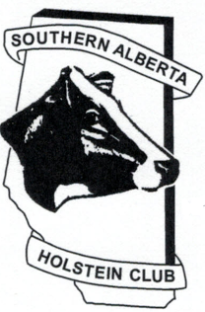
Southern Alberta Holstein Club Barn Cow of the Year Entry Form
The Rules for the Barn Cow of the Year competition are:
- $5 per entry with no more than 2 entries per class per farm, to be paid when the judge comes.
- No more than 10 entries per farm.
- Entries may not have been shown as a Lactating entry at any show.
- Entries may not have more than 12 hours of milk at time of judging.
- No clipping or fitting.
- Entries must be owned by farm, other prefixes allowed.
- Class 5 must have proof of 100,000 kg milk at time of entry/registration.

Deadline is September 15,2017
Please send the completed entry form and registration papers to sahc@live.ca

Class # Class
- First Lactation
- Second Lactation
- Third Lactation
- Fourth Lactation or more
- 100,000 kg Lifetime Milk

Class # | Ear tag # | Name | Registration # | Lact #

