

**Sale Update Sheet**

**Wednesday, October 2nd 2 p.m. CST**

**Online catalog available at** [**www.bovinebid.com**](http://www.bovinebid.com)

**Online broadcast with real time bidding available at** [**www.holsteinworld.com**](http://www.holsteinworld.com)

***Contact consignor or sale management if interested in terms on specific animals-must be pre-qualified.***

***Full payment at is due at sale for all purchases and prior the release of any animals.***

***Cattle are at the buyers risk once sold and struck off to buyer.***

***Cattle will be cared for at the buyer’s risk after the sale until Sunday, October 6th at 9 a.m.***

***Insurance is required on any animals that are not trucked the night of the sale.***

***Trucking Coordinator: Ken Hall phone 501-940-9711***

***Sale Order is Catalog Order (few minor adjustments)***

***Genomic Wonders***

Lot. 1-1A See added lots: 8 Flame pregs due June, Extremely Early Flame!!

Lot. 1-4A Genomics available sale morning

Lot. 1-5 Vi sells as a package with her Shan dtr Ri-Val-Re Shan Vivtastic-ET GTPI 2440 (housed at Ri-Val-Re Holsteins)

Lot. 1-6B One of the earliest Golden PP females in the World!

Lot. 1-7 Bombino sells in absentia entered in WDE Holstein Show, see her at Hardys Holsteins show string! One of the purest blend of show type and genomics in the breed

Lot. 1-8 All three pregnancies sells choice and privilege

Lot. 1-17 OUT

Lot. 1-18B Will be one of the earliest Main Event females

Lot. 1-19 Sells in absentia-satisfaction guaranteed

Lot. 1-21 Contract interested from Semex

Lot. 1-22 OUT

***Show Time***

Lot. 2-1 Outstanding individual! Unlimited earning potential, interest for embryos from numerous countries

Lot. 2-4 Selling Jacobs Goldsun Cory-ET Born: 6/2/13 Reg 108133850 Sire: Goldsun

Lot. 2-5 OUT

Lot. 2-12 Selling HEZ Goldchip Heaven-ET Born: 3/26/12 Reg 72688646

Lot. 2-13 OUT

Lot. 2-16 OUT

Lot. 2-17 2-11 194 16417 3.8 614 3.2 506 inc Milk wt. 74 lbs SCC 0 Herd Number 31-06-1141 Index 1141

Lot. 2-17B Selling Enfuego Goldsun America-ET Reg 142591686 Born 12/12/12

Lot. 2-18B Bred 9/20 Aftershock

Lot. 2-22 OUT

Lot. 2-22A Added lot: Ms Brasilia Epic Brady-ET sells ready to flush or breed

Lot. 2-23A Arethusa Advent Mascara-ET SELLS fresh 8/18/13 Herd Number 46-07-0171, first test 13 days fresh 81 lbs. 3.1 3.6 Dam of Lot. 2-23, see pedigree page attached

Lot. 2-25B 2#1 Halogen and 3#1 1#2 Uno X Calbrett Snowman Lainy-ET at Sunshine Genetics

Worldwide Export

***Futures Stars***

Lot. 3-1 Now EX91 EXMS

Lot. 3-1A First choice Doorman X Atwd Brandy due 9/1, guarantee three calves for choice

Lot. 3-2 Genomics pending

Lot. 3-3 Milk wt 74.4 lbs SCC 0 Herd Number 3233 Control 34HAR3233

Lot. 3-3 Milk wt 60 SCC 1 Herd Number 3219 Control 34HAR3219

Lot. 3-7 NOW VG87 VGMS

Lot. 3-10 Sells open ready to flush or breed

Lot. 3-11 Dam was lost at third calving-potential EX92-93, Pic of Vieuxsaule Toystory Peyton

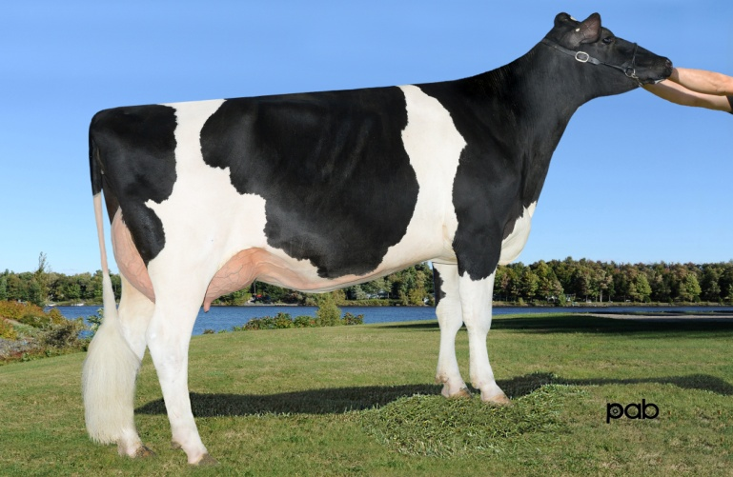

Lot. 3-12 Sells open-ready to flush or breed

Lot. 3-13 Confirmed preg carrying u/s female

Lot. 3-14 NOW VG87 Confirmed preg 7/23 service to SUPERSIRE

***All Apple***

Lot. 4-1 Apple 3 is talk of WDE!

Lot. 4-2 Top 25 RC/RED Heifer of the Breed from Apple!

Lot. 4-3 IVFed once resulting in four transfers by Save RC (Lot. 4-3A)

Lot. 4-3A 4 female transfer on 9/20/13

Lot. 4-7 Confirmed (short day) preg 9/3 Carson service listed

At $6,500 buyer gets 3#1 1#2 Sympatico X Alyse embryos

Lot. 4-9 Last test 89 lbs. 3.4 3.1 SCC 2 3-00 86 6203 3.5 219 3.0 190 inc.

Lot. 4-9A 6K GTPI 2013 3.43T

Lot. 4-10 Selling Ms Angelina Uno Angel-ET 6K GTPI 2060 3.56T 3.06UDC 3.11FLC

Lot. 4-11 1st Fall Calf Fall National R&W Show, Pull in for Jr Champion

***Red and Polled***

Lot. 5-4 Selling first choice of only two RED Sympatico X Demi Rae, 25% Down w Balance due at pick at 90 days of age, seller will pay for genomics

Lot. 5-5A First choice female by Armani or MAS from Advent Ms Meg EX92 EXMS (dam of Lot. 5-5) for full age September calves

Lot. 5-6 Petrone Agave had a heat on 9/25 and is ready to flush

Photo of Ladinodale Alise P-Red-ET, dam of Lot. 5-6

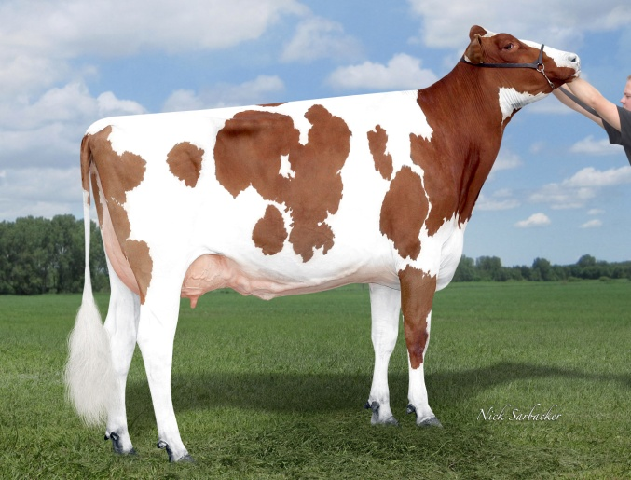

Lot. 5-7 Extreme Production and Type Pedigree-Accelerated wants to talk to new owner

Dstry Lustre is fresh and looks tremendous-should be VG this lactation, milking 90 lbs. 3.8 3.2, Embryos exported to Germany as a virgin heifer

Lot. 5-8B OUT

Lot. 5-9 8 Female Transfers on 9/20 Sire choice at sale

Lot. 5-10A 5#1 Armani DT Embryos X Married Well Gold Rascal (dam of Lot. 5-10) US Ship Only  
Lot. 5-10B 5#1 Armani DT Embryos X Married Well Gold Rascal (dam of Lot. 5-10) US Ship Only

Lot. 5-11 Obsrvr Noel now GP82 will be scored later this lactation-potential VG

Lot. 5-13 Shamrock Dana now GP83 fresh just 30 days, first test 80 lbs. 4.5 3.3

Gr Dam Deline now VG87 EX92MS milking 135 lbs.

Lot. 5-14, 5-15A-B, 6-2A-B

Planet Silk is fresh again and looks fantastic! Classification 10/9, potential EX EXMS

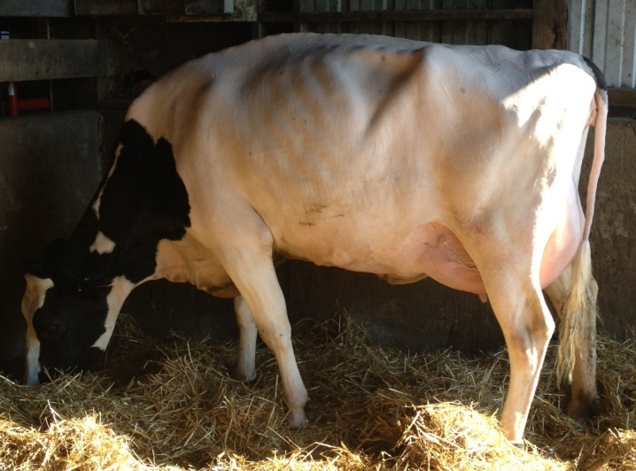

***Genomic Diamonds***

Lot. 6-1 OUT

Lot. 6-7 OUT

Lot. 6-4 Locket is NOW EX92 (max score) EX93 MS, Locket is at WDE and looks amazing!

Lot. 6-8 The ONLY Determine from Fred Felicia and FIRST OFFERING AT PUBLIC AUCTION

High genomic outcross pedigree (Determine X Freddie X Bolton X Allen X Outside X Charles) Modern health trait cow with outstanding type

Interest from every major AI to contract 63” Fred Felicia!

Dragonfly is finalist for Cow of the Year in Quebec

Lot. 6-9 The only two Supersire X Bounty! Excellent flush family-avg 15-20 embryos/flush

No embryos exported from Fred Felicia…offers over $3,000/embryo

Lot. 6-10 OUT

Lot. 6-13B OUT

Lot. 6-14 Sells in absentia, satisfaction guaranteed, balance due at pick up at 90 days of age

6-17 Bred 9/9 Doorman

***Thank you for your support of the Stars of the Universe Sale***